**\*\*\*\*rotation.cpp\*\*\*\***

**Code Explanation**

Purpose of the code: perform image rotation using inverse warping and interpolation(both nearest neighbor and bilinear interpolation)

1. template <typename T> Mat myrotate(const Mat input, float angle, const char* opt)

-input: input matrix to be rotated

-angle: rotation angle

-opt: interpolation method (if nearest-neighbor method then "nearest", else if bilinear method then "bilinear")

1) estimate size of a rectangle surrounding a rotated image(sq_row, sq_col)

float sq_row = ceil(row * sin(radian) + col * cos(radian));

float sq_col = ceil(col * sin(radian) + row * cos(radian));

2) output image를 sq_row행 sq_col열 input.type() 타입의 영행렬로 초기화한다

Mat output = Mat::zeros(sq_row, sq_col, input.type());

3) inverse warping with nearest neighbor or bilinear interpolation

//nearset integer grid의 좌표를 구한다

float y1 = floor(y);

float y2 = ceil(y);

float x1 = floor(x);

float x2 = ceil(x);

float mu = y - y1;

float lambda = x - x1;

//nearest neighbor interpolation -> use function R(u)

if (!strcmp(opt, "nearest")) {

output.at<T>(i, j) = R(lambda * (-1)) * (R(mu * (-1)) * input.at<T>(y1, x1) + R(1 - mu) * input.at<T>(y2, x1))+ R(1 - lambda) * (R(mu * (-1)) * input.at<T>(y1, x2) + R(1 - mu) * input.at<T>(y2, x2));

}

//bilinear interpolation

else if (!strcmp(opt, "bilinear")) {

output.at<T>(i, j) = lambda * (mu * input.at<T>(y2, x2) + (1 - mu) * input.at<T>(y1, x2)) +

(1 - lambda) * (mu * input.at<T>(y2, x1) + (1 - mu) * input.at<T>(y1, x1));

}

2. float R(float u)

:function for nearest-neighbor interpolation

-> 1 if -0.5<u<=0.5 otherwise 0

3. int main()

-input: read "lena.jpg" using imread() function

-rotated: rotated image matrix

**Results**

original image

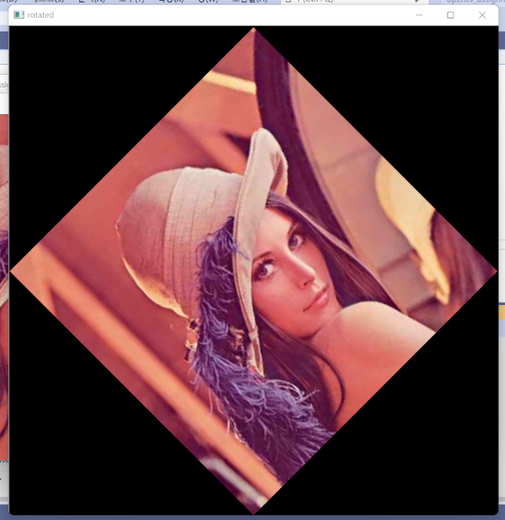 45 degree rotation(nearest neighbor)

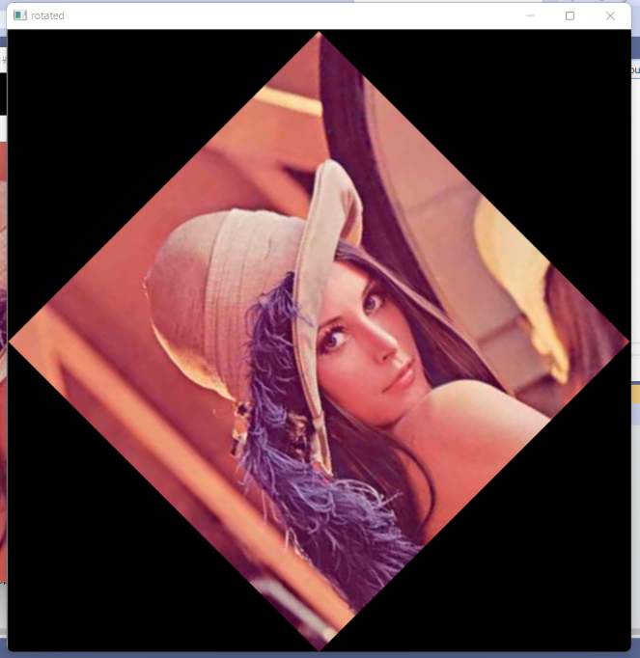 45 degree rotation(bilinear)

* Image with bilinear method has better quality than nearest neighbor method

**\*\*stitching.cpp\*\***

**Code Explanation**

Purpose of the code: perform image stitching with two images "Img01.jpg" and "Img02.jpg" using affine transformation

1. template <typename T> Mat cal_affine(int ptl_x[], int ptl_y[], int ptr_x[], int ptr_y[], int number_of_points)

:function to obtain affine transform

-ptl_x[], ptl_y[], ptr_x[], ptr_y[]: corresponding pixels which will be used to calculate affine matrix

-number_of_points: number of points

->return x= (M^T * M)^(−1) * M^T * b , so we can find a,b,c,d,e,f of affine matrix A

2. void blend_stitching(const Mat I1, const Mat I2, Mat& I_f, int bound_l, int bound_u, float alpha)

:function to merge two images I1, I2

-I1, I2: matrix of image to be blended

-I_f: merged image

-bound_l, bound_u: boundary for merged image(I_f)

-alpha: when blending I1 and I2 use alpha*I1 + (1-alpha)*I2

I-f={ alpha*I1 + (1-alpha)*I2 (if both I1 and I2 are valid)

I1 (if only I1 is valid)

I2(if only I2 is valid)

0 (otherwise) }

if (cond_I2) //if both l1, l2 are valid

I_f.at<Vec3f>(i - bound_u, j - bound_l) = alpha * I1.at<Vec3f>(i, j) + (1 - alpha) * I_f.at<Vec3f>(i - bound_u, j - bound_l);

else //if only l1 is valid

I_f.at<Vec3f>(i - bound_u, j - bound_l) = I1.at<Vec3f>(i, j);

3. int main()

1) read each image

I1 = imread("C:\\Users\\MIN\\Desktop\\Lab02\\Img01.jpg", IMREAD_COLOR);

I2 = imread("C:\\Users\\MIN\\Desktop\\Lab02\\Img02.jpg", IMREAD_COLOR);

2) convert l1(l2) into : l1*alpha + beta (l2*alpha + beta )

(alpha=1.0/255 , beta= 0.0(default parameter) )

I1.convertTo(I1, CV_32FC3, 1.0 / 255);

I2.convertTo(I2, CV_32FC3, 1.0 / 255);

3) I1_row, I1_col, I2_row, I2_col: height(row), width(col) of each image

4) compute corners (p1, p2, p3, p4) using A21

-> A21.at<float>(0), ..., A21.at<float>(5)는 affine matrix A21의 a,b,c,d,e,f

Point2f p1(A21.at<float>(0) * 0 + A21.at<float>(1) * 0 + A21.at<float>(2), A21.at<float>(3) * 0 + A21.at<float>(4) * 0 + A21.at<float>(5));

Point2f p2(A21.at<float>(0) * 0 + A21.at<float>(1) * I2_row + A21.at<float>(2), A21.at<float>(3) * 0 + A21.at<float>(4) * I2_row + A21.at<float>(5));

Point2f p3(A21.at<float>(0) * I2_col + A21.at<float>(1) * I2_row + A21.at<float>(2), A21.at<float>(3) * I2_col + A21.at<float>(4) * I2_row + A21.at<float>(5));

Point2f p4(A21.at<float>(0) * I2_col + A21.at<float>(1) * 0 + A21.at<float>(2), A21.at<float>(3) * I2_col + A21.at<float>(4) * 0 + A21.at<float>(5));

5) bound_u, bound_b, bound_l, bound_r: compute boundary for merged image

6) initialize merged image

Mat I_f(bound_b - bound_u + 1, bound_r - bound_l + 1, CV_32FC3, Scalar(0));

7) inverse warping with bilinear interplolation using A12

for (int i = bound_u; i <= bound_b; i++) {

for (int j = bound_l; j <= bound_r; j++) {

float x = A12.at<float>(0) * j + A12.at<float>(1) * i + A12.at<float>(2) -bound_l;

float y = A12.at<float>(3) * j + A12.at<float>(4) * i + A12.at<float>(5) - bound_u;

//nearest integer grid

float y1 = floor(y);

float y2 = ceil(y);

float x1 = floor(x);

float x2 = ceil(x);

float mu = y - y1;

float lambda = x - x1;

if (x1 >= 0 && x2 < I2_col && y1 >= 0 && y2 < I2_row)

I_f.at<Vec3f>(i - bound_u, j - bound_l) = lambda * (mu * I2.at<Vec3f>(y2, x2) + (1 - mu) * I2.at<Vec3f>(y1, x2)) +(1 - lambda) * (mu * I2.at<Vec3f>(y2, x1) + (1 - mu) * I2.at<Vec3f>(y1, x1));

}

}

8) image stitching with blend

blend_stitching(I1, I2, I_f, bound_l, bound_u, 0.5);

I_f = 0.5*I1 + 0.5*I2’

9) show l1,l2, and stitched image

10) convert l_f into : l_f*alpha + beta ( alpha=255.0 , beta= 0.0(default parameter) )

I_f.convertTo(I_f, CV_8UC3, 255.0);

11) write I_f into “result.png”

imwrite("result.png", I_f);

**Results**

left image

right image

Stitched image(alpha=0.5)